INSTRUCTIONS ON HOW TO CONVERT OPENEPHYS FILES DAT FILES FOR SPIKE DETECTION AND CLUSERING.

1. Run the matlab code ‘***ConvertOpenEphys_2_dat.m***’ making sure the current folder is where the code is located, currently *Y:\Saleem Lab\Data\ePhys\AAA_FileConverter*. This needs accessory functions, namely *‘load_open_ephys_data_faster.m’*, *‘remap_32ch.m’, ‘save2dat.m’, ‘uigetfile_n_dir.m’*.

* The code uses a function to re-order the channels so that they are organised according to their physical location in the probe. Please double check that this file is consistent with the probe you use.

1. When prompted with the following window, please select the folder or multiple folders containing the openephys data.

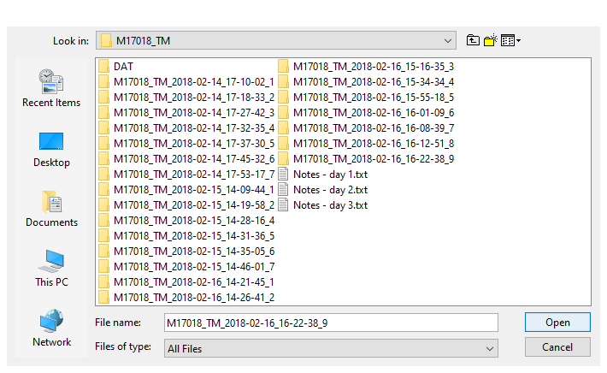

1. Now the program will load all the channels of one file at a time. You can follow the progress from the Matlab Command Window.

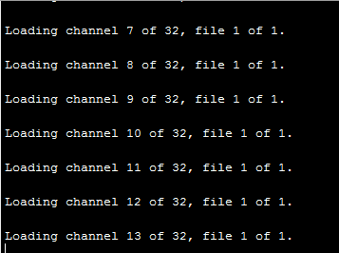

1. You then have to select where you want to save the .dat file.

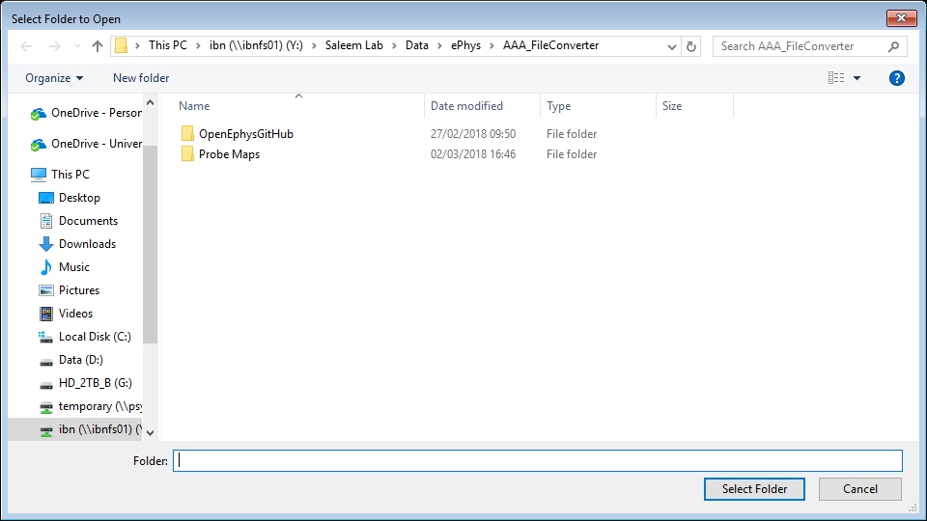

1. Now you have to insert the name of the .dat file, directly from the Matlab Command Window.

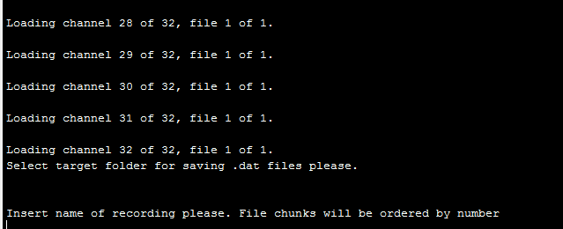

1. Now the code will save the .dat file into the target folder. Once finished you will get a message on the Matlab Command Window.

Potential changes:

* Directory structure and destination folders predefined.
* File naming automated
* File identifying added at the end of the filename in case we want to try different runs

**Probe Channel Mapping:**

The identification number of a recording channel has to be mapped from the probe to OpenEphys system due to different channel ordering of the connectors/adapters. This is important because it allows to discriminate channels from different shanks and analyse units from truly proximal channels.

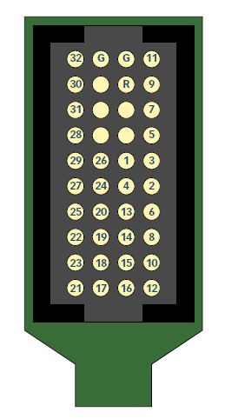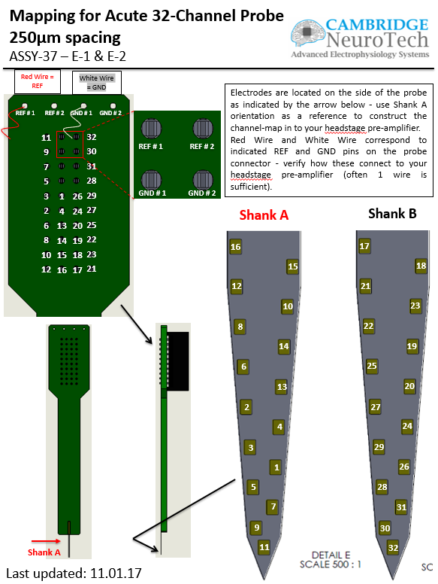For example, the double shank Cambridge NeuroTech probe E series, with 16 shanks per shank has the following channel disposition:

Fortunately the probes from Neuronexus (above) and Cambridge Neuro Tech (left) have the same ordering so one mapping should be OK for all our 32-channel probes.

It is important to note that first, the channels are positioned in a not-straightforward order and second, the connector at the top of the probe shows which pin transmits which channel signal.

This connector (A32) is then attached to an adaptor A32-OM32 whose mapping is as follows:

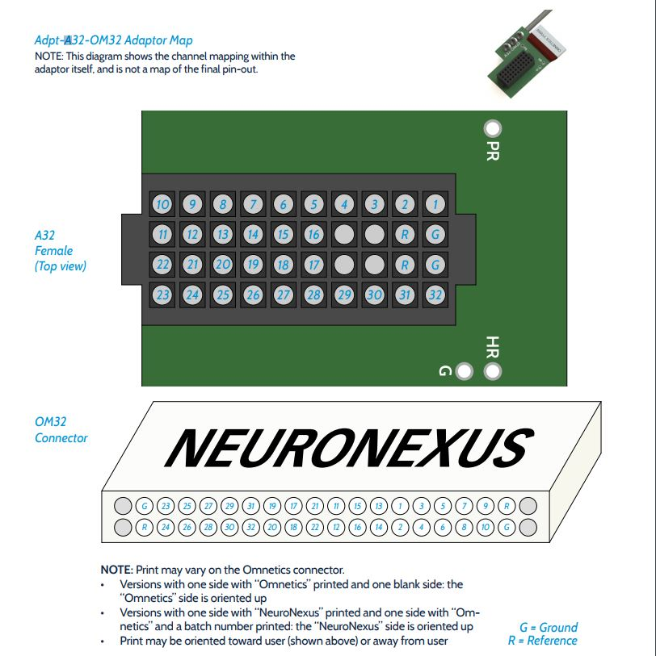

From these 2 first pictures we can already notice that the ID channel numbers between the A32 female of the adaptor do not match those for the male of the probe itself. For example, channel 11 of the probe connects to PIN 1 of the A32 female of the adaptor, channel 9 to pin 2 and so on.

Another adaptor is required to connect the probe to the OpenEphys system, the RHD2132 connector (see next page). For example: PIN 23 of the A32-OM32 adaptor connects with PIN 7 (8-1 as starts from 0) of the RHD2132 amplifier board, or PIN 9 connects with PIN 22 (23-1).

This is the last stage before the signals go to the OpenEphys system and we assume that the signals that are displayed onto the recording software are ordered according to the scheme of this last adaptor. Therefore, if we take the two examples of the previous paragraph, the 22nd signal shown on the OpenEphys system will be the one coming from the electrode site number 23; the 7th signal will be coming from the 12th recording site. And so and so forth.

For this purpose, I created a mapping that takes these info into account and reorder the signals according to the recording site of origin at the moment of conversion from OpenEphys (.continuous) to .DAT format.

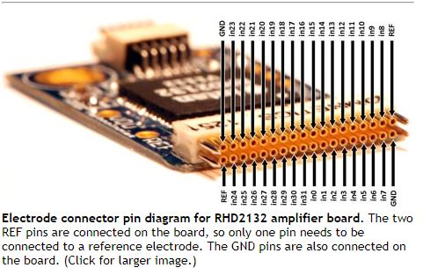The next step is to make sure the geometrical information of the probe are correctly fed into the clustering software. So, for each probe is necessary to create a geometry file *.prb that contains: adjacency info of the channels and their 2D physical coordinates onto each shank (preferably in micrometers.)